Project Design Phase Solution Architecture

Date | 20 February 2026
Team ID | LTVIP2026TMIDS66141
Project Name | IntelliSQL: Intelligent SQL Querying with LLMs  Using Gemini Pro
Maximum Marks | 4 Marks

Solution Architecture:
Solution Architecture bridges the gap between business needs and technical implementation. For IntelliSQL, the goal is to ensure a scalable, responsive, and secure Text-to-SQL system using Streamlit, Python, and Google Gemini AI, with clear data flow for administrators and non-technical users.
Objectives of the Architecture:
- Define Component Interaction: Establish how the Streamlit UI, Gemini API, and SQLite database interact.
- Separation of Concerns: Maintain clear boundaries between the UI, AI logic, and data storage.
- Smooth Data Flow: Enable rapid translation of natural language into SQL and immediate data retrieval.
- Support Future Scaling: Allow for easy upgrades to more powerful LLMs (e.g., Gemini Pro) or cloud databases.

Architecture Layers and Components:

Layer | Components / Tools Used | Description
Frontend | Streamlit, HTML/CSS | Web interface featuring a dark theme and sidebar navigation for Home, About, and Query pages.
Backend | Python, Google Generative AI SDK | Core logic for prompt engineering, SQL generation via Gemini Flash, and Regex-based sanitization.
Database | SQLite (data.db) | Local relational storage for the STUDENTS table including Names, Classes, Marks, and Companies.
Security | .env (python-dotenv) | Secure management of the GOOGLE_API_KEY to prevent exposure in source code.
Dev Tools | Git, VS Code, Regex | Development environment used for building, testing, and isolating valid SQL from AI responses.

Data Flow Summary
- User Journey:
  - User accesses dashboard → inputs natural language question → system attaches context prompt → Gemini generates SQL → Regex cleans query → data displayed in table.
- Admin/System Journey:
  - System loads API key → initializes database connection → validates
SQL commands against the STUDENTS table schema.

Example - Solution Architecture Diagram:

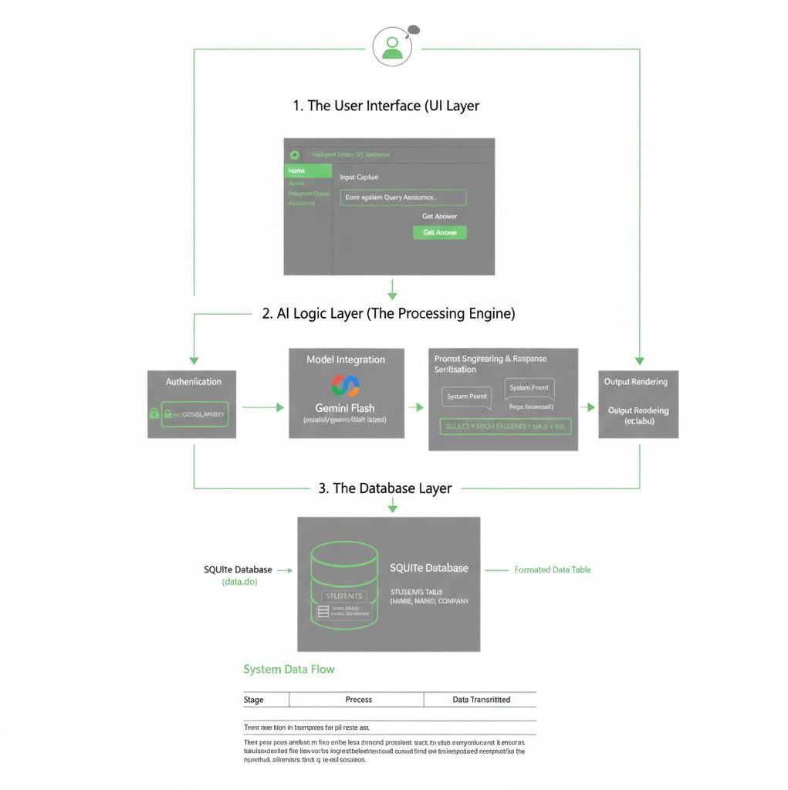

Feature | Handled By | Status
Natural Language Processing | Google Gemini Flash | ✔ Implemented
SQL Extraction/Cleaning | Python Regex (re) | ✔ Implemented
Database Persistence | SQLite | ✔ Implemented
Secure Key Handling | .env, python-dotenv | ✔ Implemented
Modular UI Navigation | Streamlit Sidebar | ✔ Implemented
Performance Optimization | Gemini 1.5 Flash Model | ✔ Optimized

Notes:
- The current design supports future enhancements like multi-table joins, voice- to-query integration, and export-to-CSV features.
- The modular 3-tier architecture ensures that the database can be migrated to a cloud-based SQL server (e.g., PostgreSQL) without rewriting the AI logic.

